Ideation Phase

Define the Problem Statements

Date | 15 Feb 2026
Team ID | LTVIP2026TMIDS85401
Project Name | Strategic Product Placement Analysis
Maximum Marks | 2 Marks

Customer Problem Statement :

Retail companies, merchandising teams, and category managers face significant challenges in identifying which product placements drive higher sales, customer engagement, and profitability. Sales data is often stored in raw transactional formats, making it difficult to understand in-store buying behavior, product adjacency impact, seasonal demand patterns, and shelf performance across different store locations.
Without proper visual analytics tools, analyzing how product positioning influences purchasing decisions becomes inefficient and highly dependent on manual reporting. This lack of clear, centralized insight prevents decision-makers from optimizing shelf layouts, promotional placements, cross-selling strategies, and store-level merchandising performance.
There is a critical need to compare product performance across different time periods (for example, Year 1 vs Year 2 or Quarter-wise comparisons) to understand how placement strategies, promotional campaigns, and seasonal variations impact revenue and customer purchase patterns.
By developing an interactive visual analytics solution (using tools like Tableau or Power BI), stakeholders can:
- Track sales performance by product category and shelf position
- Identify high-performing placement zones (eye-level, end-cap, checkout, etc.)
- Compare time-based trends (monthly, quarterly, yearly)
- Analyze store-wise and region-wise product movement
- Detect cross-selling and bundling opportunities
This interactive data storytelling approach transforms static retail sales data into actionable merchandising intelligence, enabling strategic decisions that directly improve revenue, customer experience, and operational efficiency.

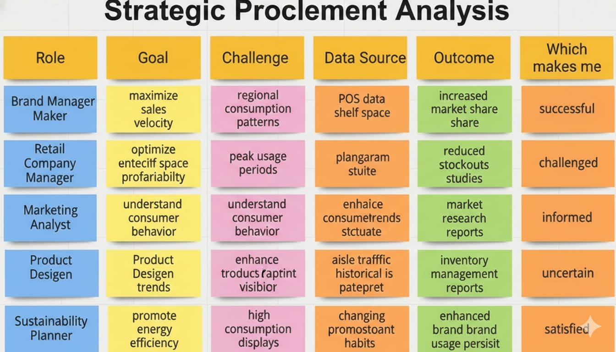
satisfiedd

PS ID | I am | I’m trying to | But | Because | Which makes me feel
PS-1 | a retail merchandising manager | identify which product placements drive maximum sales and footfall | sales data is scattered across POS systems | there is no centralized placement analytics dashboard | uncertain about shelf optimization decisions
PS-2 | a category manager | compare product performance across stores, regions, and time periods | I can’t filter sales by placement zone and season accurately | reports are generic and not placement-focused | frustrated and unable to maximize category revenue
PS-3 | a retail operations executive | present placement performance insights to senior management | reports lack visual clarity and persuasive storytelling | dashboards are static and not interactive | ineffective during strategic review meetings
PS-4 | a marketing & promotions analyst | understand how placement, discounts, and seasonality affect product sales | I cannot easily analyze correlations between layout and revenue | existing tools don’t allow deep drill-down analysis | stuck and unable to recommend data-driven strategies

